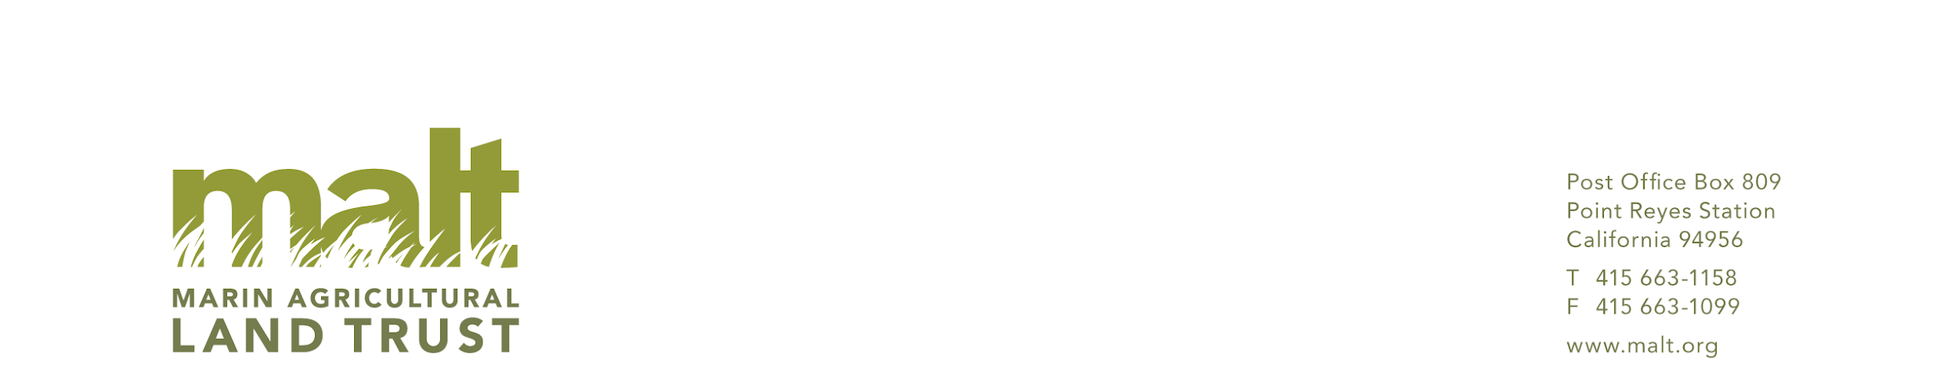  
  
Sample Language for a Bequest

**General Gift for MALT’s Mission**

You can arrange to make an unrestricted gift to MALT in your will or living trust by adding wording like this to your will or trust document, providing MALT with the flexibility to allocate funds where the need is greatest:

*“I leave [ ____ percent of my estate, or description of asset, or ___________ dollars] to the Marin Agricultural Land Trust (MALT), tax I.D. 94-2689383, located in Point Reyes Station, California, to be used for general purposes and ongoing operating support.”*

**Gift for a Designated Purpose**

If you wish to support a specific MALT program or initiative with your gift, this language can be used to reflect your wishes:

*“I give [ ____ percent of my estate, or description of asset, or ___________ dollars] to the Marin Agricultural Land Trust (MALT), tax I.D. 94-2689383, located in Point Reyes Station, California for the following restricted purpose: “*

### **Flexibility of Your Gift**

If circumstances change over time, you can also add language that allows MALT to adjust the use of your donation. Here is an example of flexible language:

*“If the designated program or initiative is no longer in need of funding, MALT may use the funds for another program that is closest in alignment with my original intent.”*Once you have consulted with an attorney to incorporate the appropriate language into your will or living trust, please let us know! We’d like to thank you for your generosity, make sure the purpose of your gift is understood by us, and recognize you as a member of the [Phyllis Faber Legacy Giving Circle](https://malt.org/legacy/).

Thank you for considering making a planned gift to MALT so that we can continue protecting the farms, ranches, and open space of West Marin, forever.